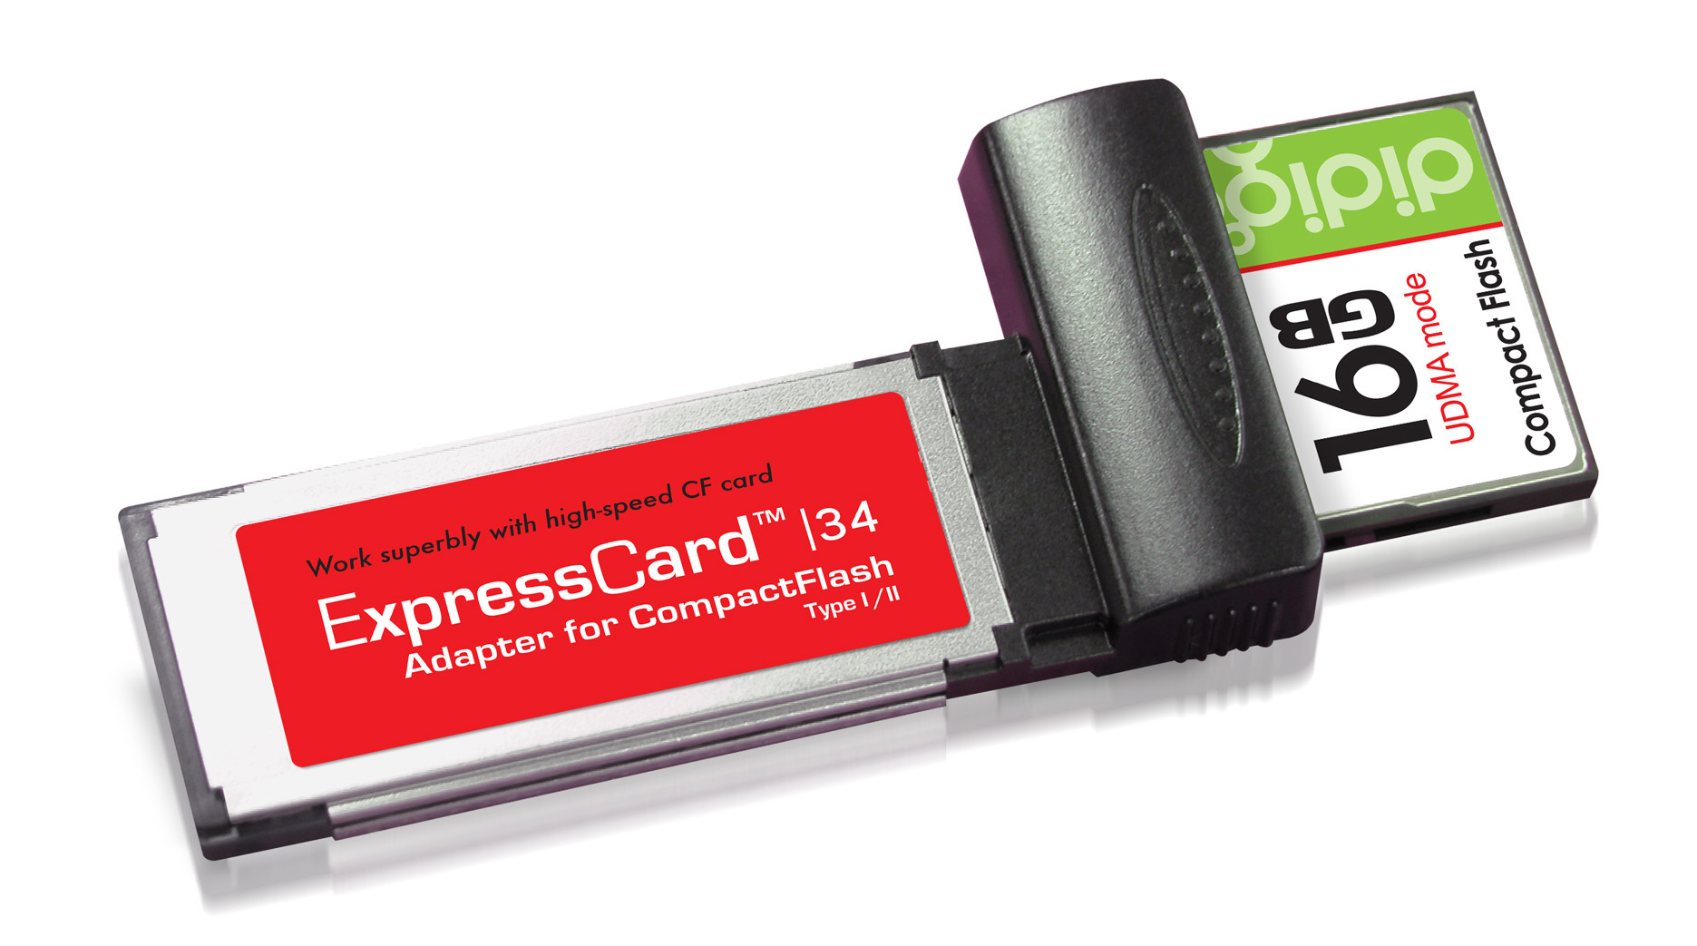

User Manual & Driver Installation Guide
for
ExpressCard Adapter for Compact Flash Type I / II (PCI-e interface)

Table of Content
Section A : User Manual |  | Page
A.1 | Features | 3
A.2 | How to use | 4
A.3 | Specifications | 5
Section B : Driver Installation Guide
B.1 | Important Information – MUST READ | 6
B.2 | How to install the driver under Microsoft Windows | 6
B.3 | How to install the driver under Mac OS | 8
B.4 | How to un-install the driver | 11
Section A -- User Manual

A.1 Features

Thank you for choosing this ExpressCard Adapter for Compact Flash (Type I / II). This Adapter is an extremely fast reader for transferring data between high-speed CF (Type I / II) and Notebook/Computers with ExpressCard slot.

Unlike most of the memory card readers and adapters commonly available in the market, this ExpressCard Adapter is operated under the PCI-Express interface. That is to say, its theoretical throughput is at least 5 times faster than that of USB 2.0 interface. For Compact Flash with UDMA mode, the data transfer speed can reach up to 96 MB/sec*.

With the following features, this adapter is the perfect solution for users with high-speed CF card and looking for maximum capability, efficiency and data throughput:

- Suitable for computers / laptops equipped with ExpressCard™ 34 or ExpressCard™ 54 slot ;
- Support Compact Flash Type I, Compact Flash Type II, PIO mode, and UDMA mode (according to Compact Flash Spec. Rev. 4.1) ;
- Extremely high speed for Compact Flash with UDMA mode, data transfer speed (sequential read / write) up to 96 MB/sec* ;
- Reliable and rugged stainless steel cover ;
- Power supply from ExpressCard socket and no external power required ;
- Support power saving mode to reduce power consumption ;
- Support future new card specifications through driver upgrade.

Minimum System Requirements
- Mac OS 10.4.x, 10.5.x, 10.6
- Windows XP, Vista, 7

* Based on internal testing as performance figure will vary depending upon different host environment.
Section A -- User Manual

A.2 How to Use

First-time Use
This Adapter requires the installation of the driver provided in this CD disk. Please install the driver for the First-time Use of this Adapter in your Notebook system.

Refer to Section B on how to install the driver.

Use of this Adapter in transferring data
1) Please install the driver first before using the Adapter
2) Plug-in the CF card into the Adapter
3) Insert the Adapter with card into the ExpressCard slot (either 34 or 54) of your notebook (as shown in the picture below)

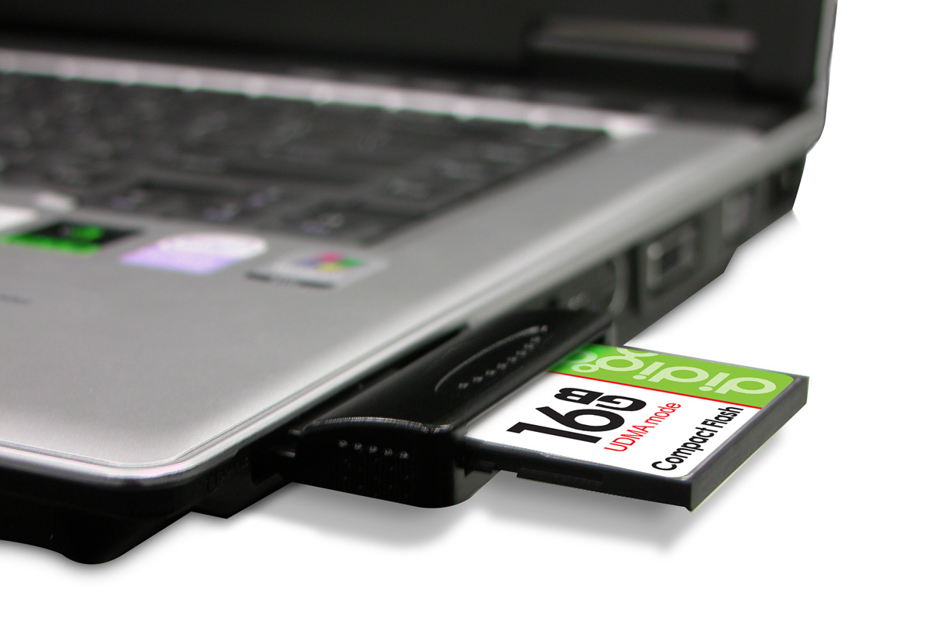

4) In few seconds, this Adapter will be recognized by the operating system of your notebook. Then, you can start viewing / copying data between memory card and computer via this Adapter.

Remark:
The procedure Step 2) and 3) could be swapped.

Section A -- User Manual

A.3 Specifications

- Link interface：High Speed PCIe Spec. Rev. 1.0a (Data transfer rate up to
2.5Gbps)
- Memory card standard compliant：Compact Flash Spec. Rev. 4.1
- Dimensions：101 x 55 x 10 mm (L x W x H)
- Weight：25 g
- OS supported：Windows XP / Vista / 7, Mac 10.4.X / 10.5.X / 10.6
- Operating power：+3.3 VDC (+/-5% wide range power supply)
- Environment support：
  - Working @ 0℃ to 55℃ (Temp.); 0 ~ 50% (RH)
  - Storage @ -20℃ to 65℃ (Temp.); 0 ~ 90% (RH)

Section B – Driver Installation Guide

B.1 Important Information – MUST READ

After installing the driver, please have the adapter with CF card inserted into the ExpressCard slot

B.2 How to install the driver under Microsoft Windows

This section describes the procedures for installing the “Driver” provided in this CD under Windows XP / Vista / 7

- Please refer to the following procedure for installing Windows driver before using the Adapter
- Insert the Driver CD into CD/DVD Drive, the following screen will pop-up
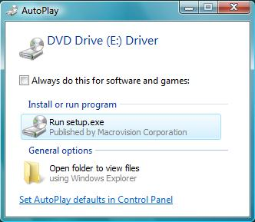

(Double-click for running setup.exe)
* If the above screen does not show up, double-click “setup.exe” under the folder “Windows” on the CD
- The installation wizard will activate as follows, click “Install” to proceed
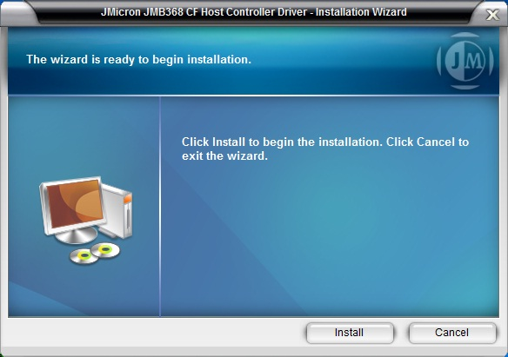

(D) Click “Install”, the driver will begin the installation
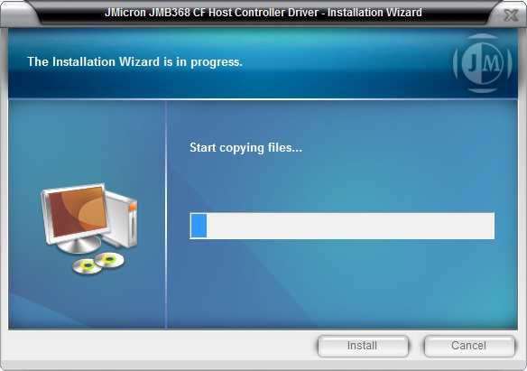

(E) Upon completing the installation, please click “Finish”
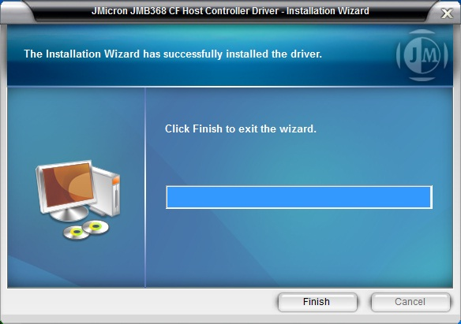

B.3 How to install the driver under Mac OS

Important:
Driver installation is needed for Mac OS 10.4.x, 10.5.x and 10.6 by the following procedure below
  - Please refer to the following procedure for installing Mac Driver before using the Adapter
  - Insert the Driver CD into CD/DVD player, under the folder “Mac”, double-click the file named “JMicronATA”

  - The Driver Installer will activate as follows, click “Continue” to proceed
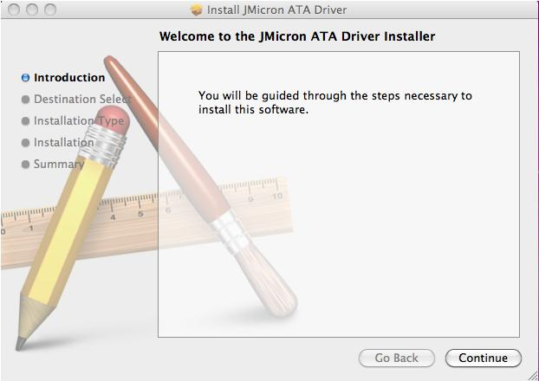

  - Select Destination Drive and Click “Install” to proceed
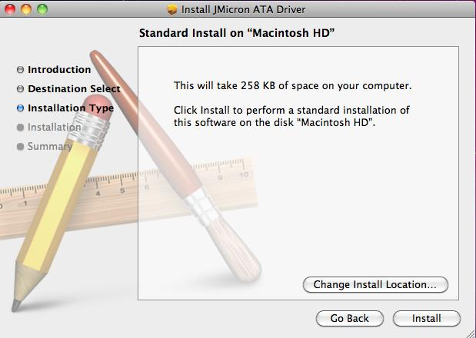

  - Click “Continue Installation”, the driver will begin the installation
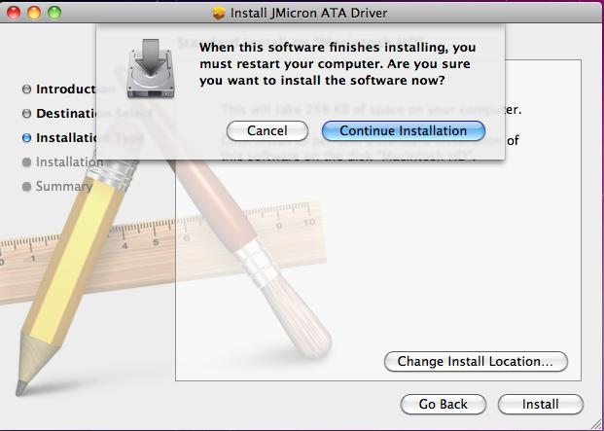

  - Upon completing the installation, please click “Restart”
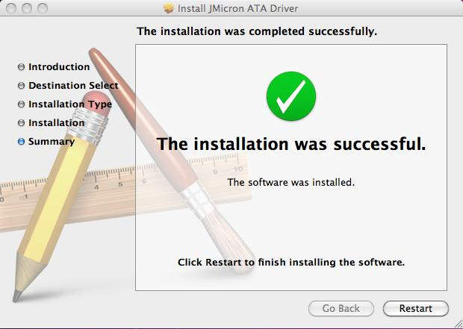

B.4 How to Un-install the driver

For Windows OS:
- In the “Control Panel”, double-click the icon “Programs and Features”
- Select “JMicron JMB368 CF Host Controller Driver” and right-click for removing the program from the system
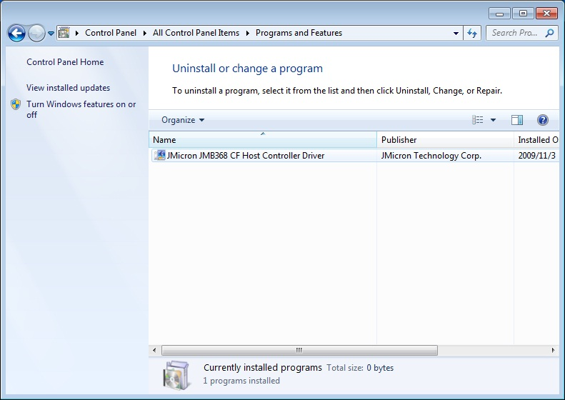

For Mac OS:
- Insert the Driver CD into CD/DVD player, under the folder “Mac”, double-click the file named “JMicron_Driver_Remover”
- It will activate as follows, click “OK” for removing the program from the system
